**Section 0 -Use GIT as local VCS. Steps to follow:**

1. **Create a directory ‘project_dir’ & cd to ‘project_dir’.**

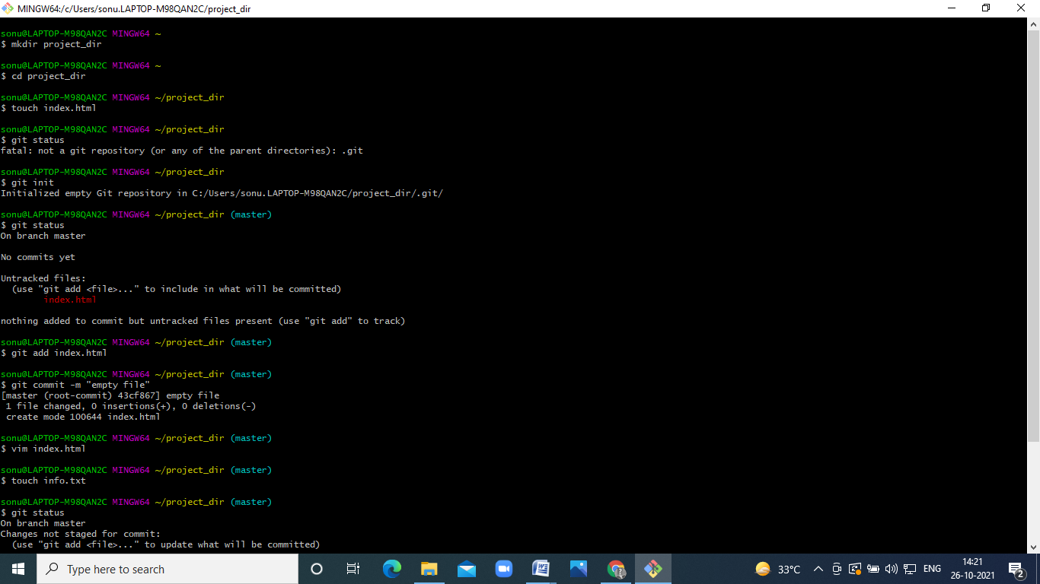

1. **Initialize git version database. (git init)**

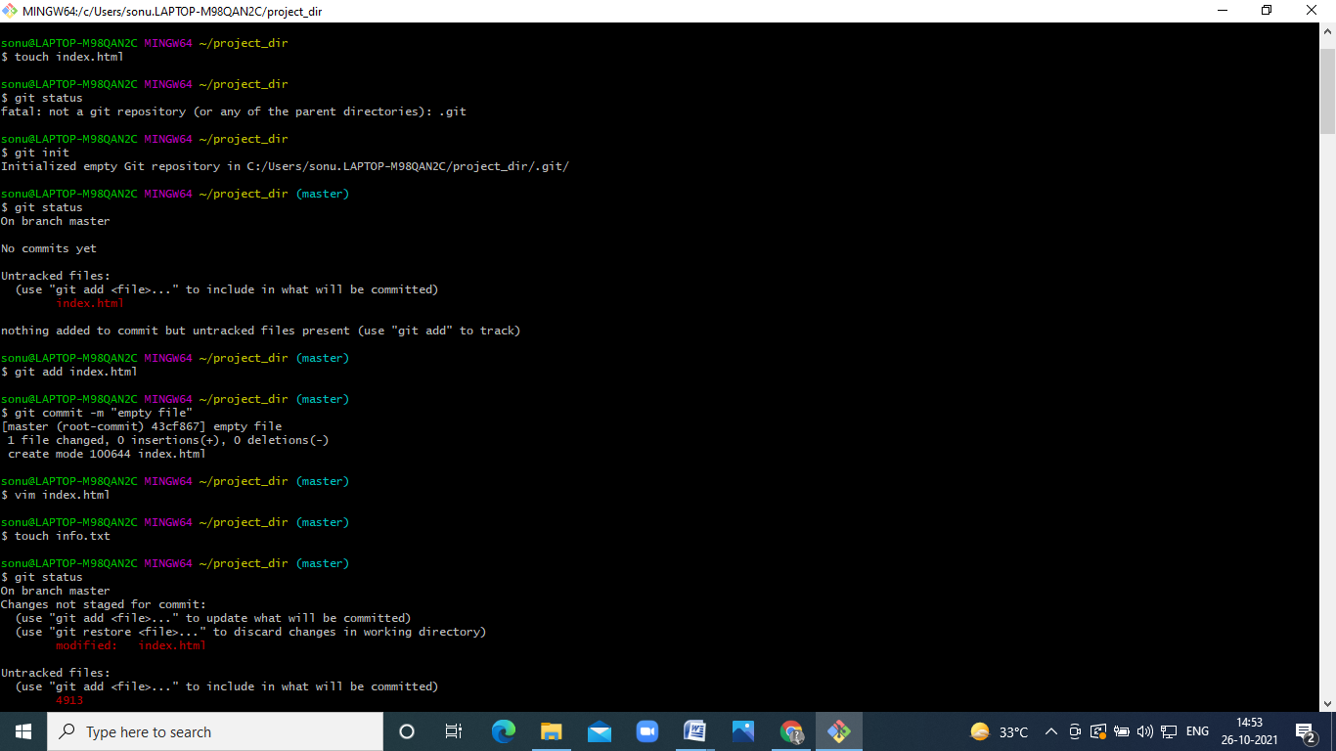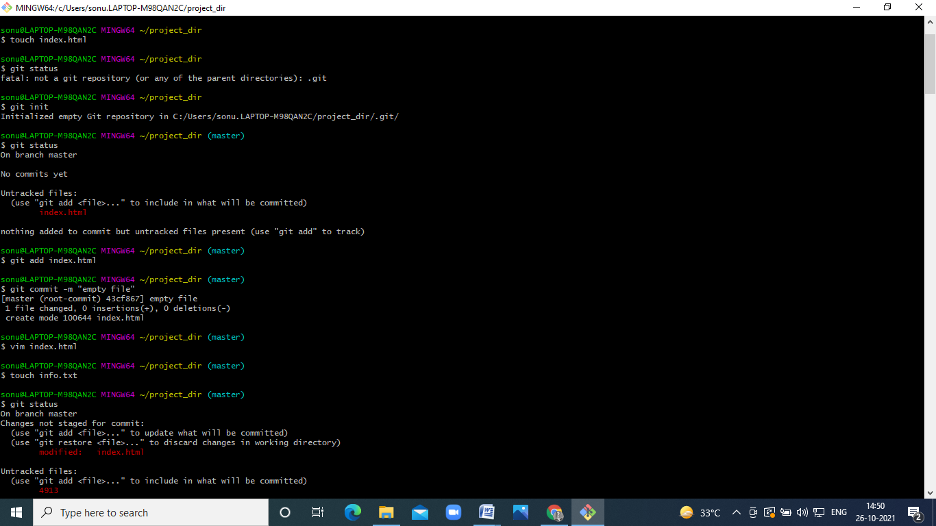

1. **Check the git status. You should find index.html as untracked file.**
2. **Stage the index.html file.**



1. **Commit index.html**



1. **Make few changes in index.html & create a new file info.txt file**.



1. **Check git status. You should find index.html & info.txt as untracked files.**

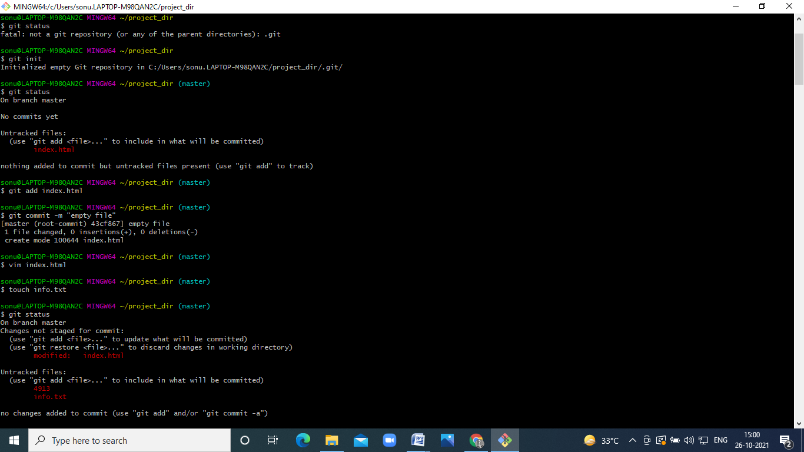

1. **Configure GIT to ignore all txt files.**

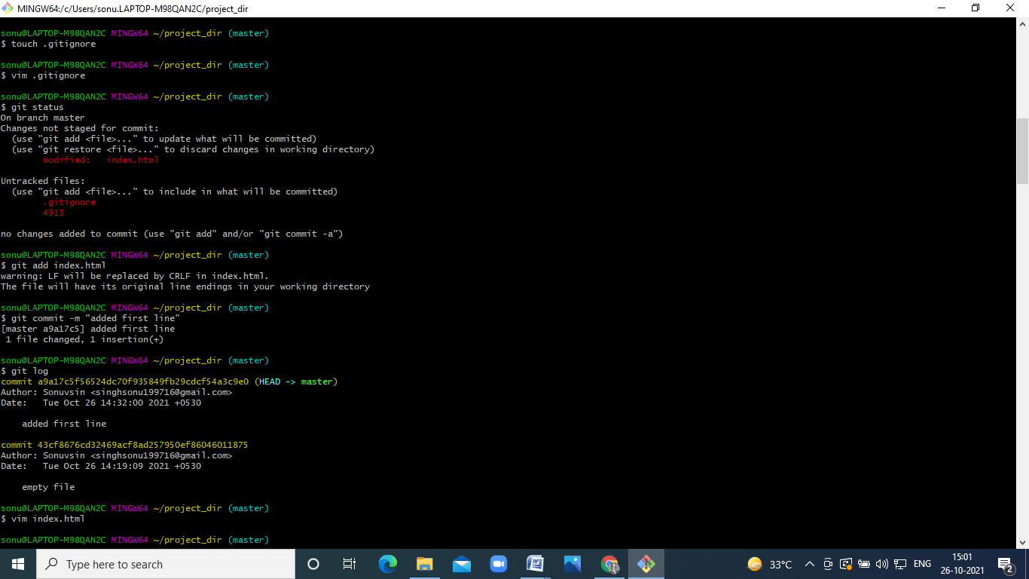

1. **Again check the git status. You should find only index.html as untracked file.**

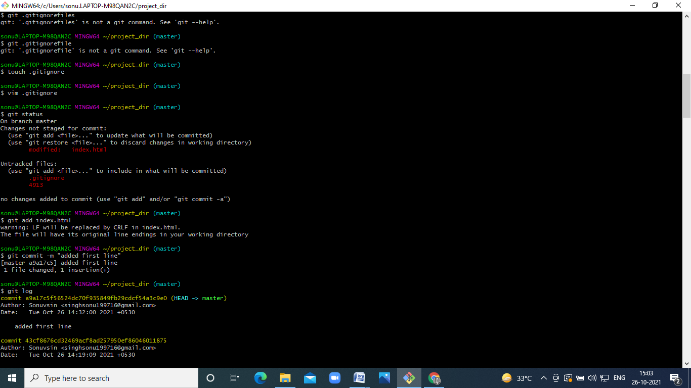

1. **State & commit index.html**



1. **Log all your comments so far.**

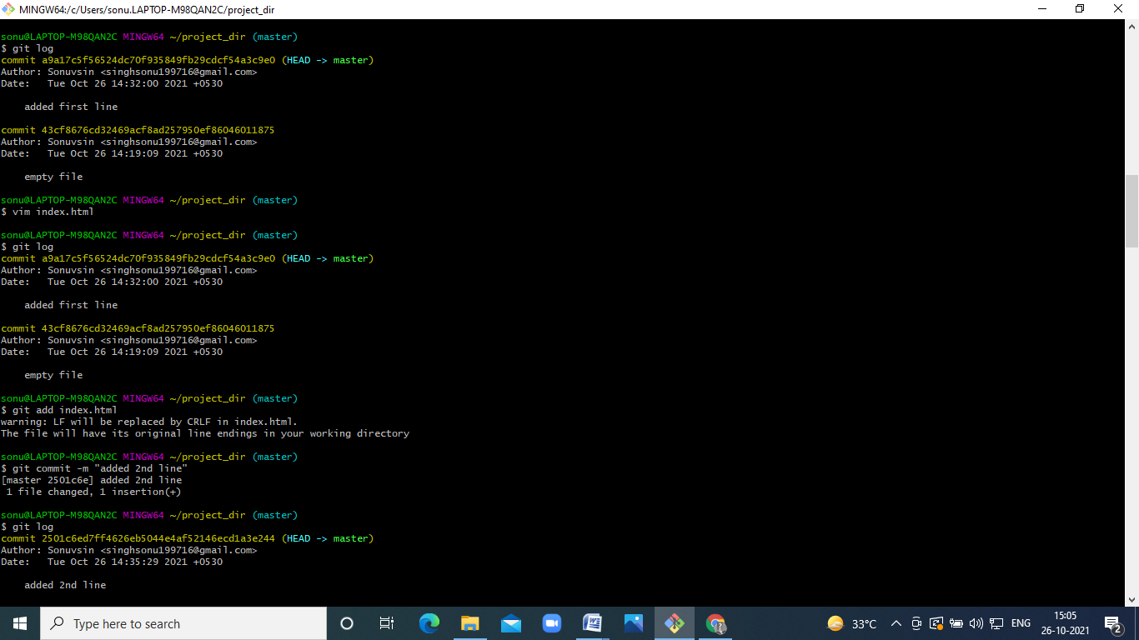

1. **Make some changes in index.html.**



1. **Revert the change made in the previous step using git command.**

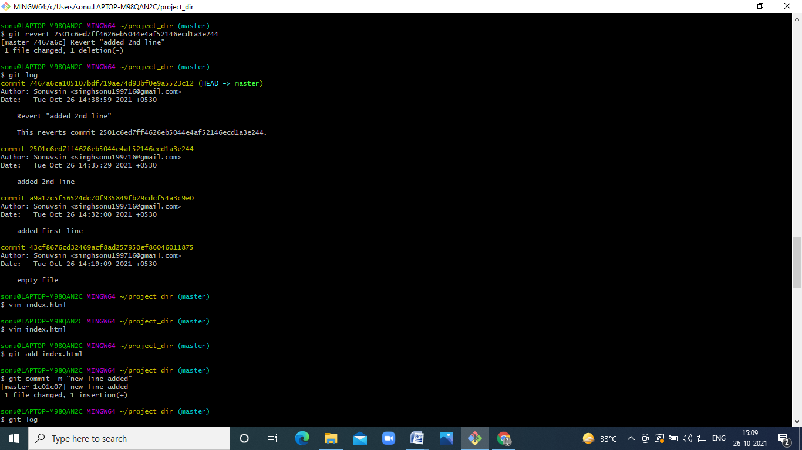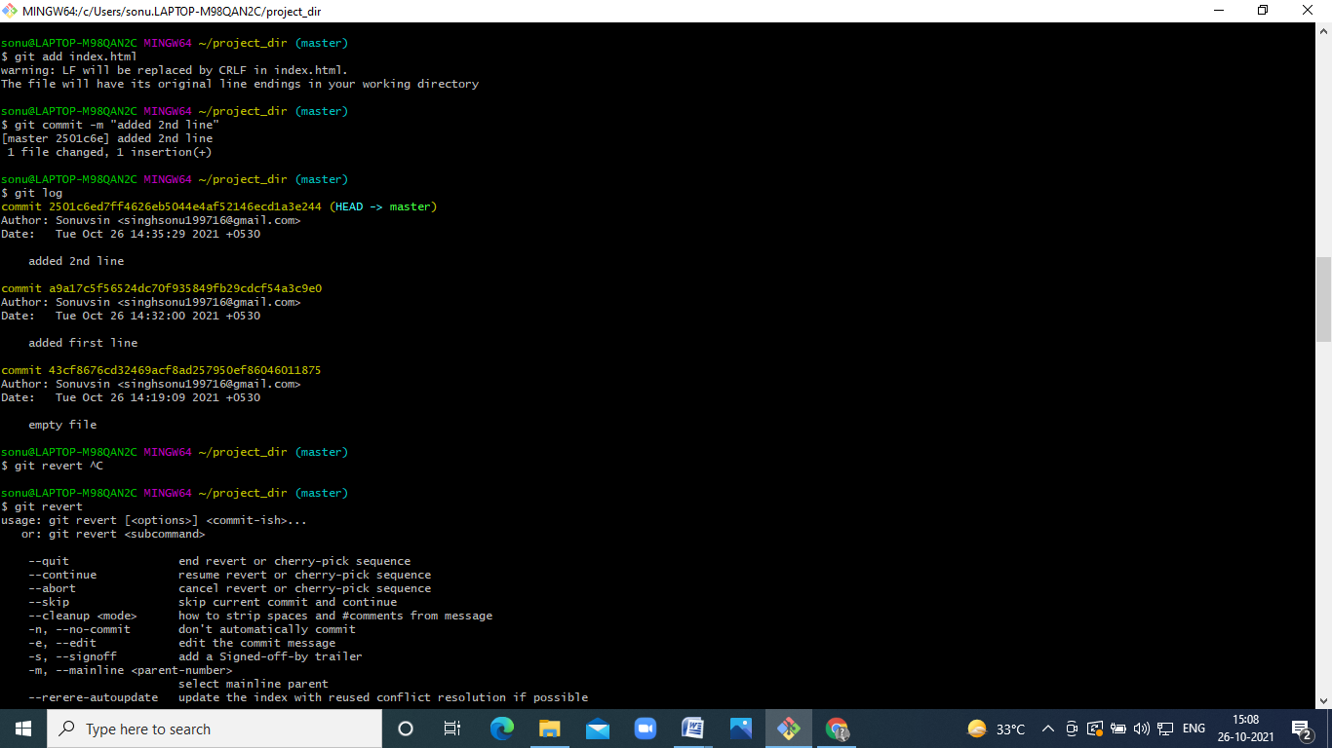

1. **Again change index.html.**

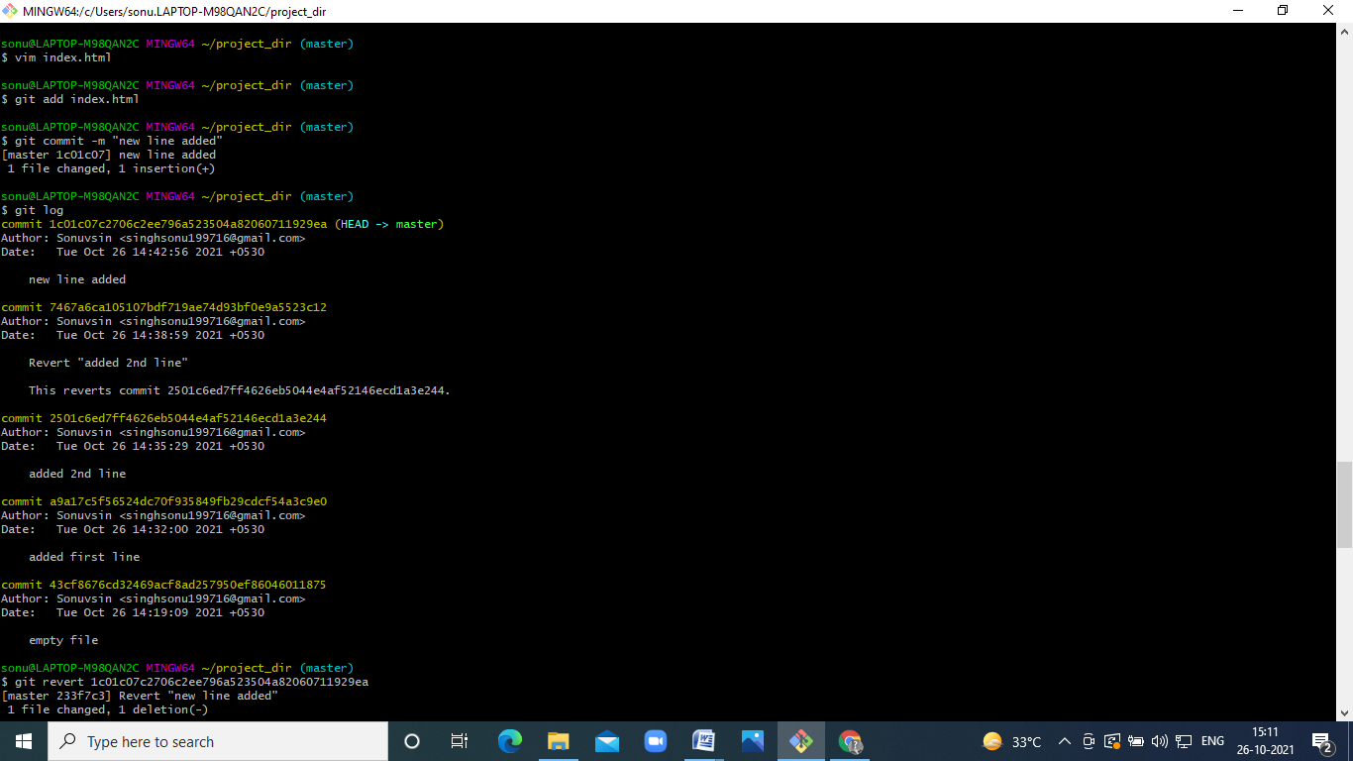

1. **Stage index.html**



1. **Revert back the last stage.**

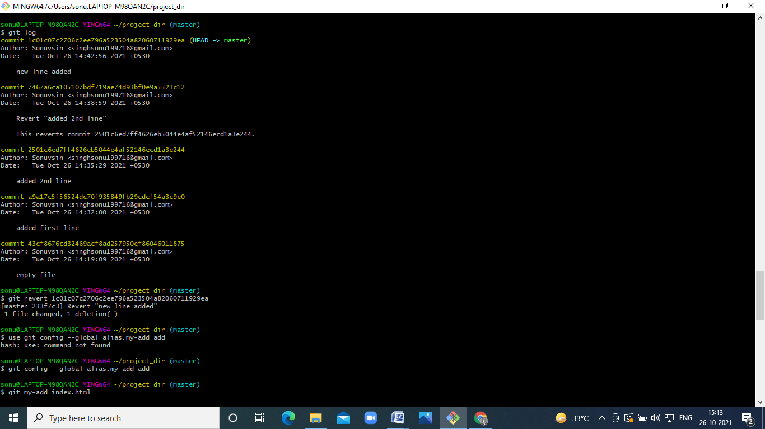

**18.Rename ‘add’ command to ‘my-add’.**

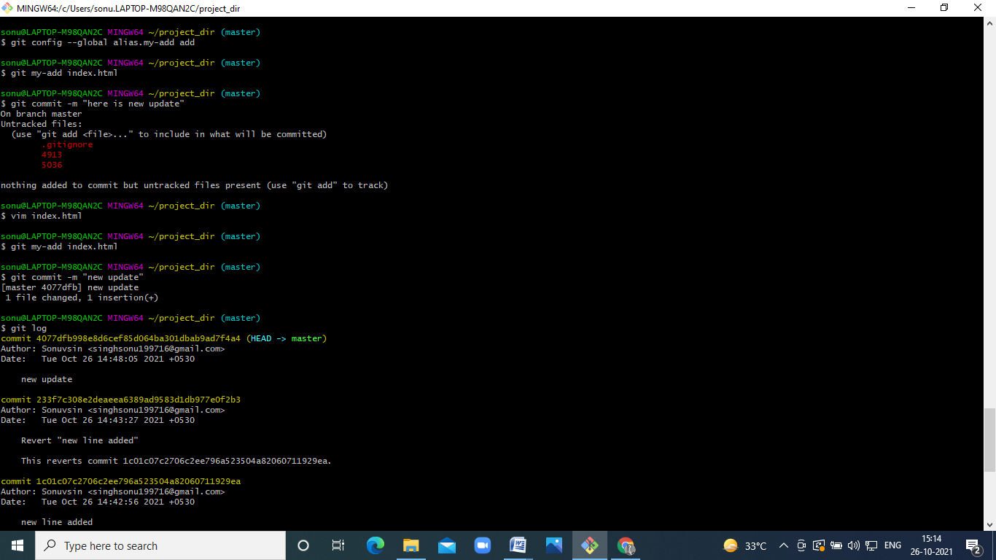

**19.Using my_add command Stage index.html again & commit the changes.**



**20.Revert the last commit.**

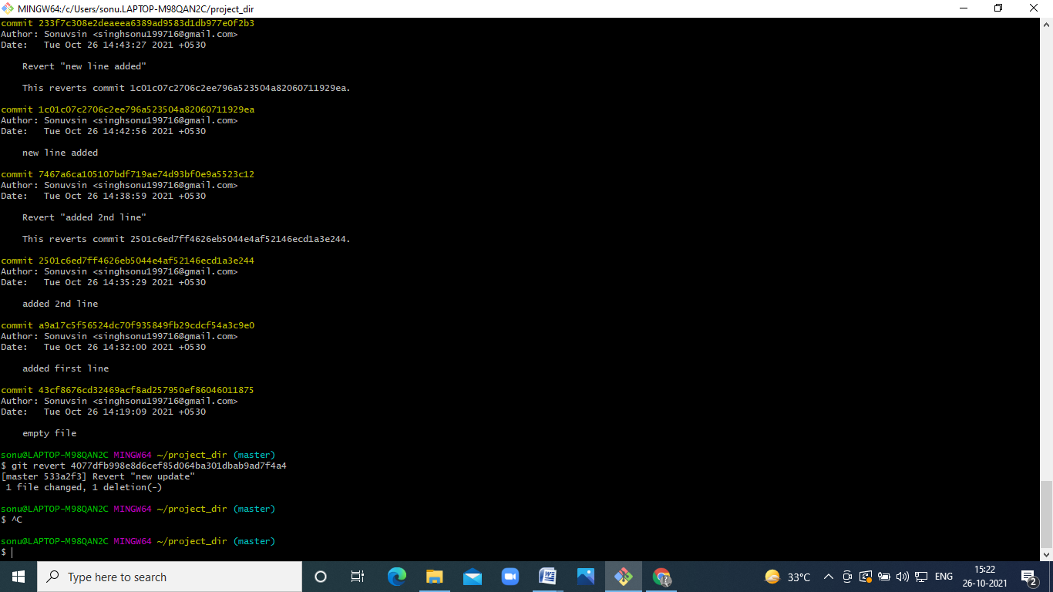

**Section 1**

1. First take a backup of your assignments & projects. This is required because due to incorrect GIT operation you may lose your files.
2. Create an empty directory ‘Assignments’ & cd to ‘Assignments’.

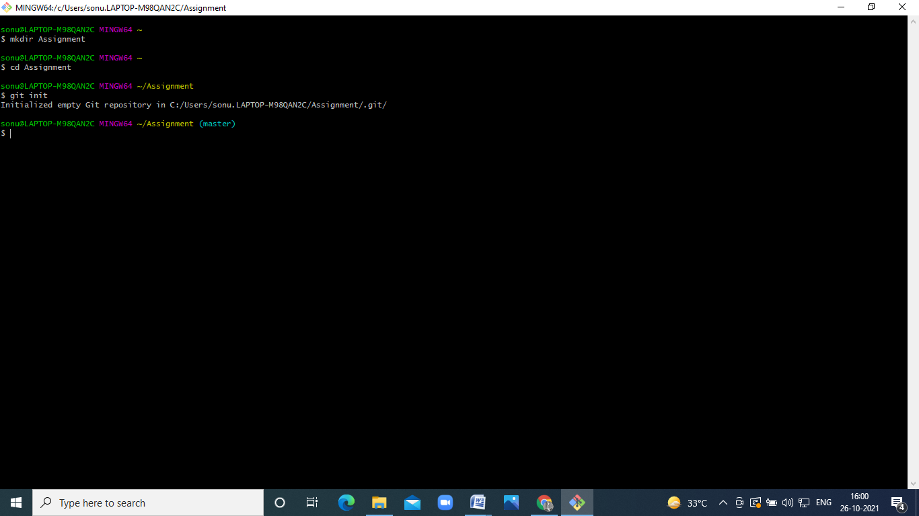

1. Create a file README.txt inside ‘Assignments’ & write few lines about the contents of ‘Assignments’ folder.

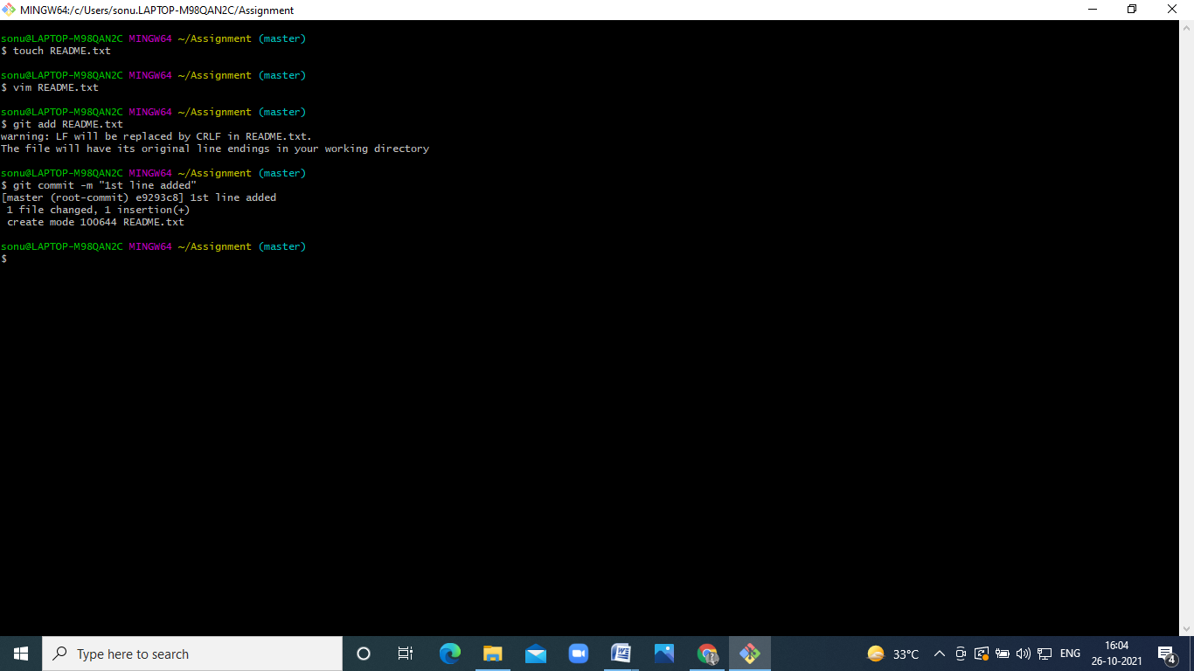

1. Commit README.txt file.



1. Now create a new branch ‘html-assignments’.

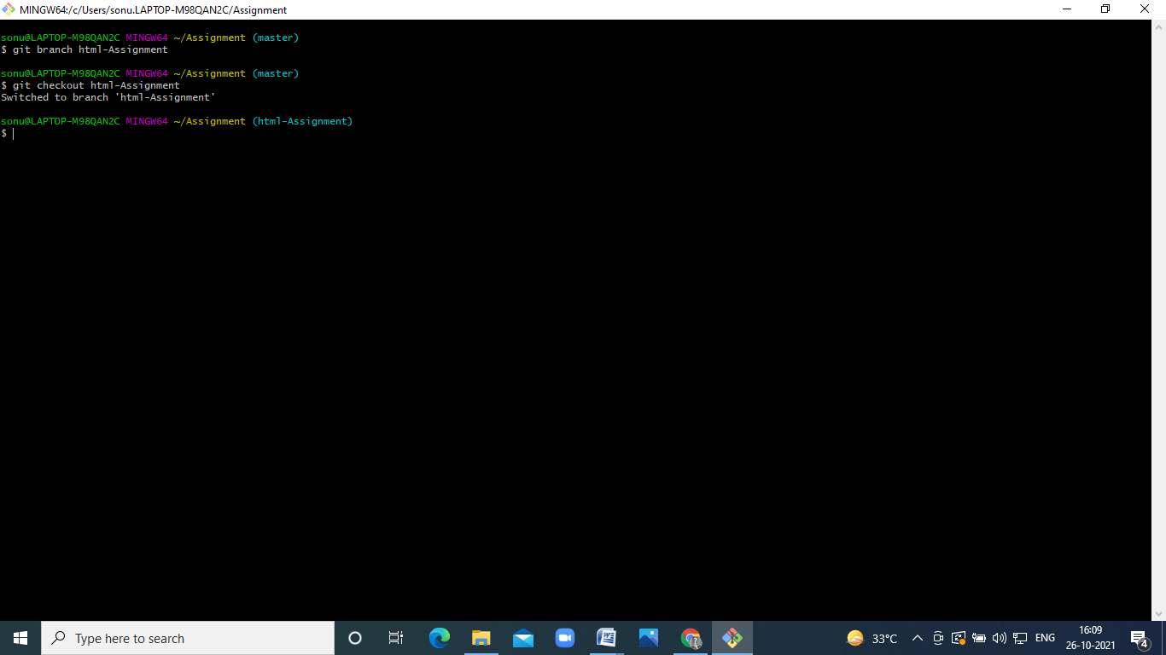

1. Switch to ‘html-assignments’ branch.



1. Copy all HTML assignments inside ‘Assignments’ folder

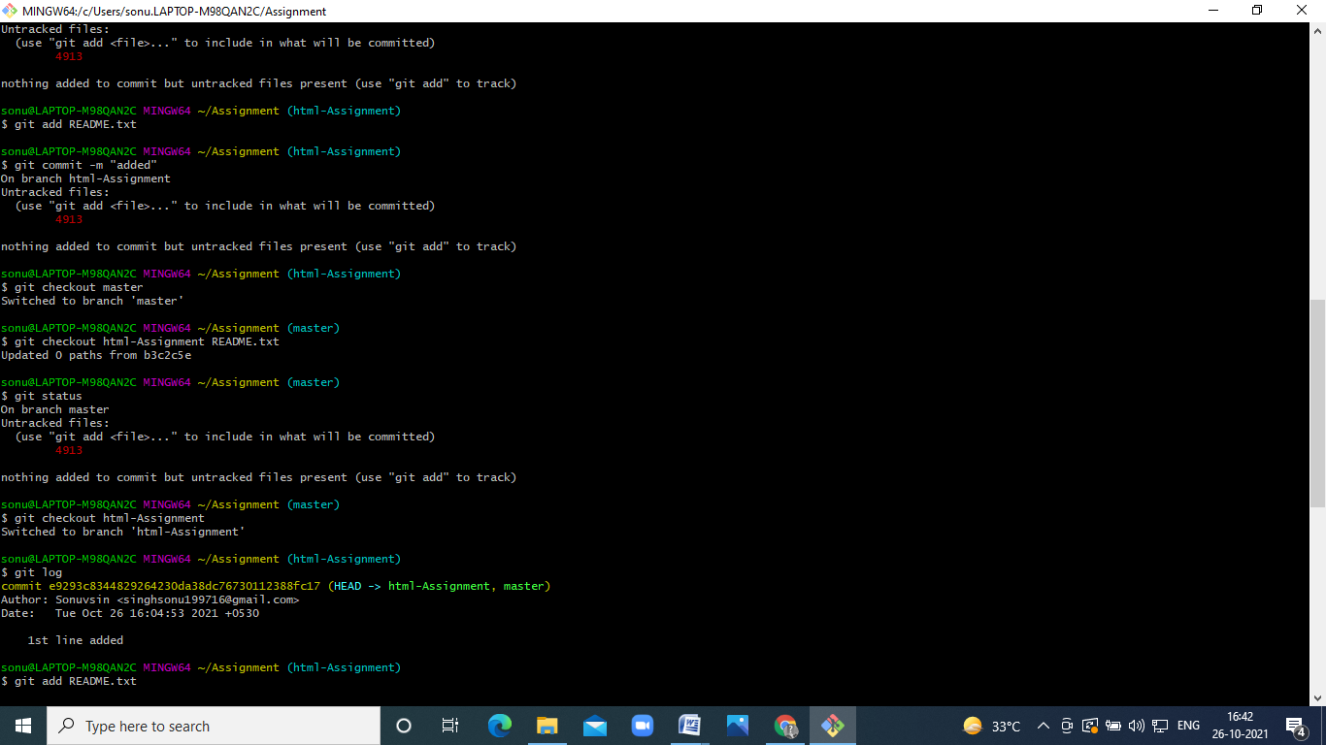

.

1. Commit HTML assignments into ‘html-assignments’ branch. 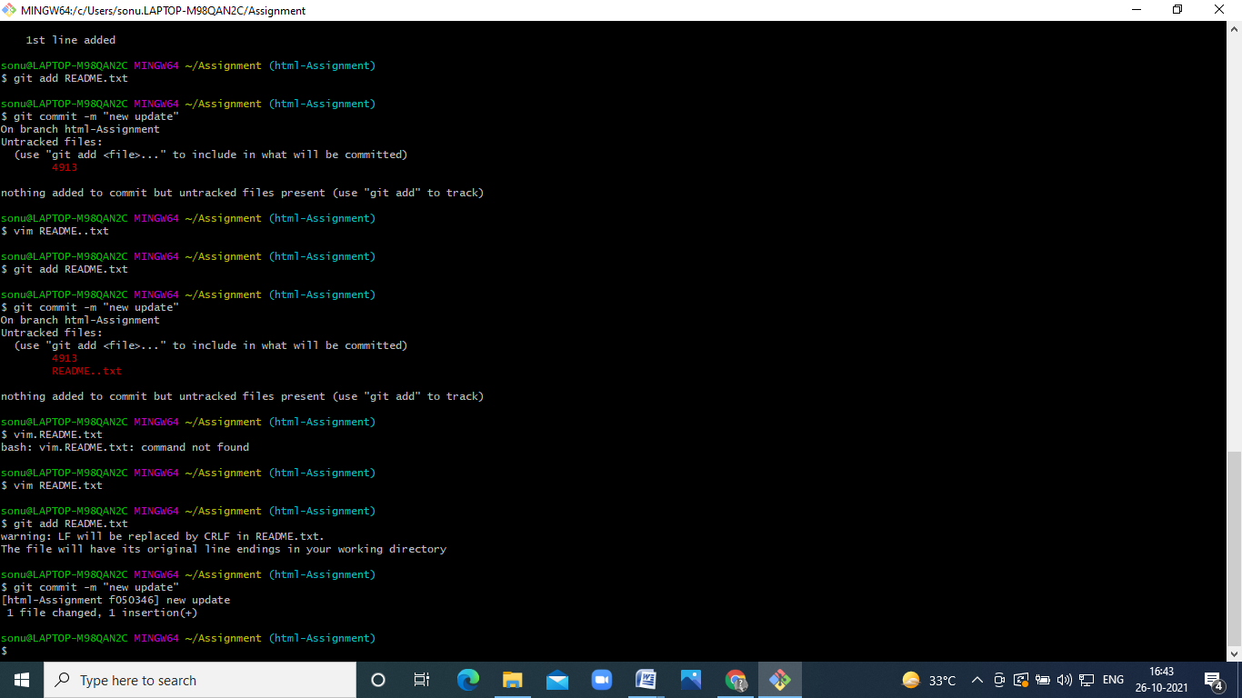
2. Make minor changes into few files belonging to ‘html-assignments’ branch.

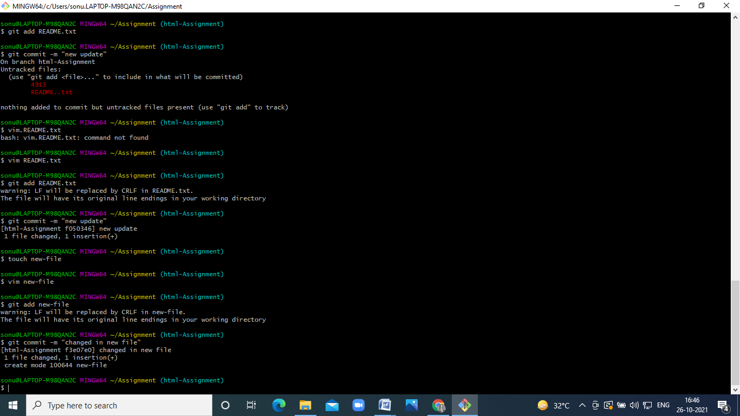

1. Commit those changed files.



1. Switch to master branch.

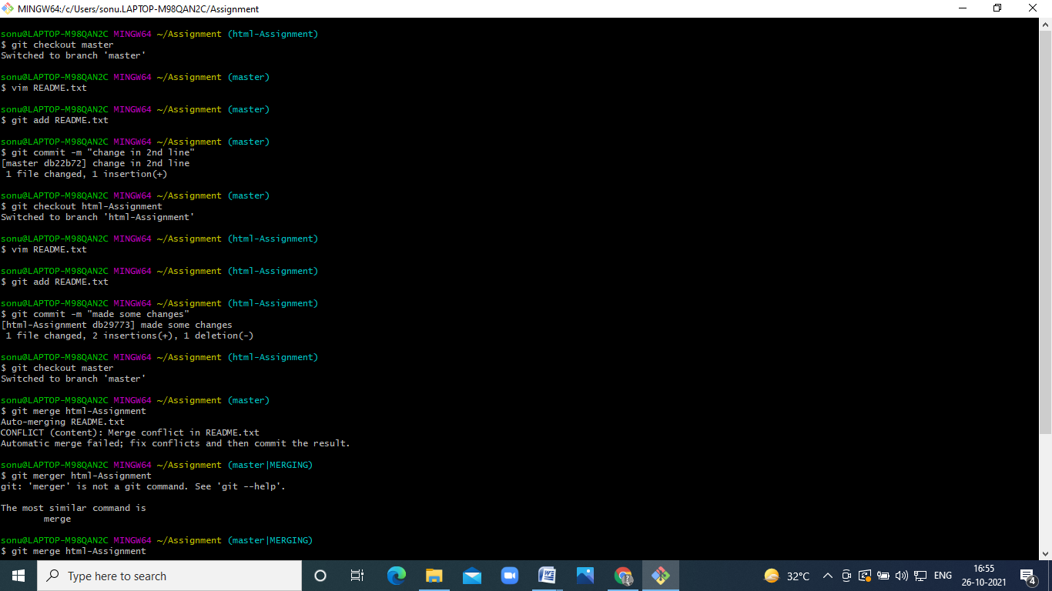

1. Make minor changes into README.txt file & commit those changes into master.



1. Again switch to ‘html-assignments’ branch.



1. Make minor changes into few files belonging to ‘html-assignments’ branch.



1. Commit those changes

.

1. Switch to master.



1. Merge ‘html-assignments’ branch into master. Confirm all html assignments are shown in master.

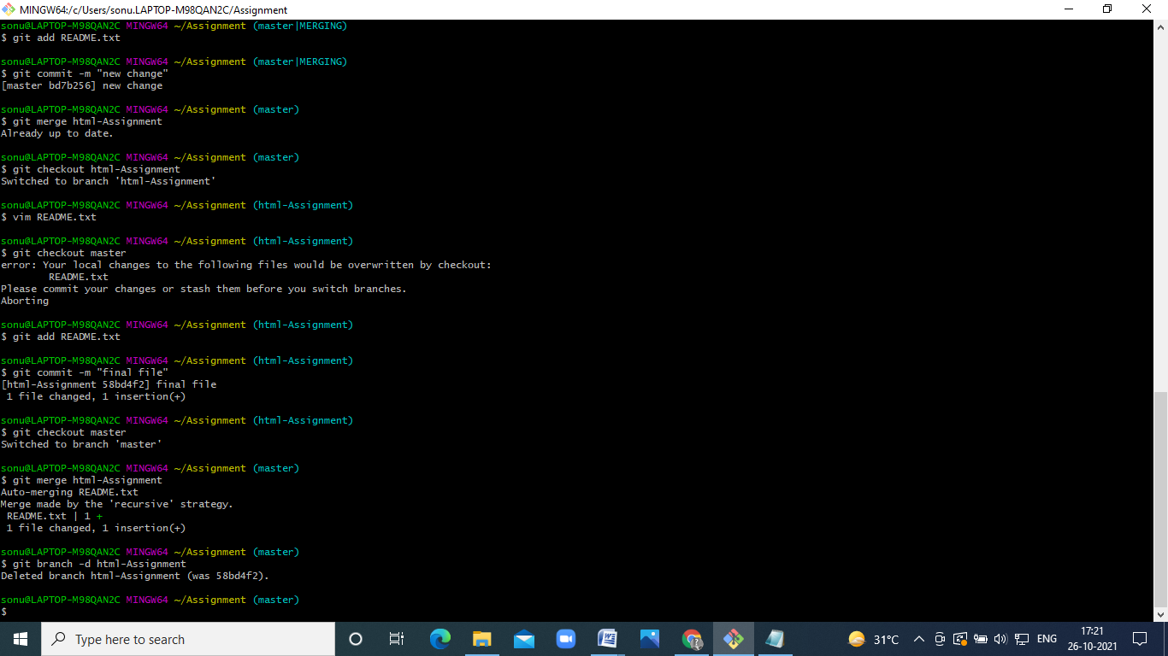

1. Finally delete the ‘html-assignments’ branch.



SECTION-2 - (CSS assignments) Steps to follow:

1. Create a new branch ‘css-assignments’.

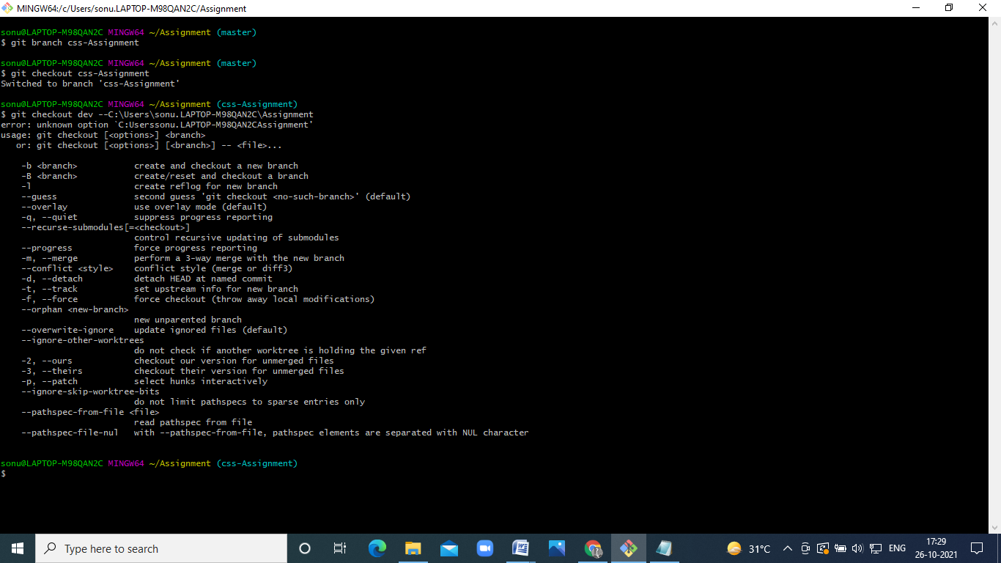

1. Switch to ‘css-assignments’ branch.



1. Copy all CSS assignments inside ‘Assignments’ folder.

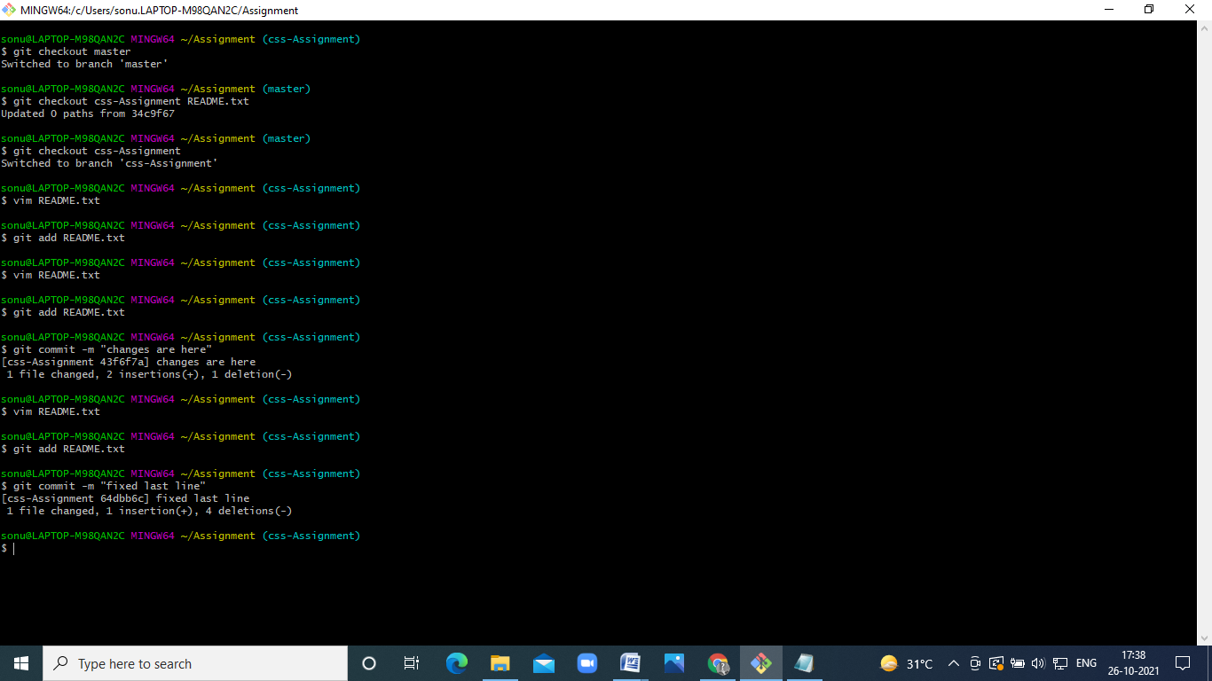

1. Commit CSS assignments into ‘css-assignments’ branch.



1. Make minor changes into README.txt file on line 1 belonging to ‘css-assignments’ branch.

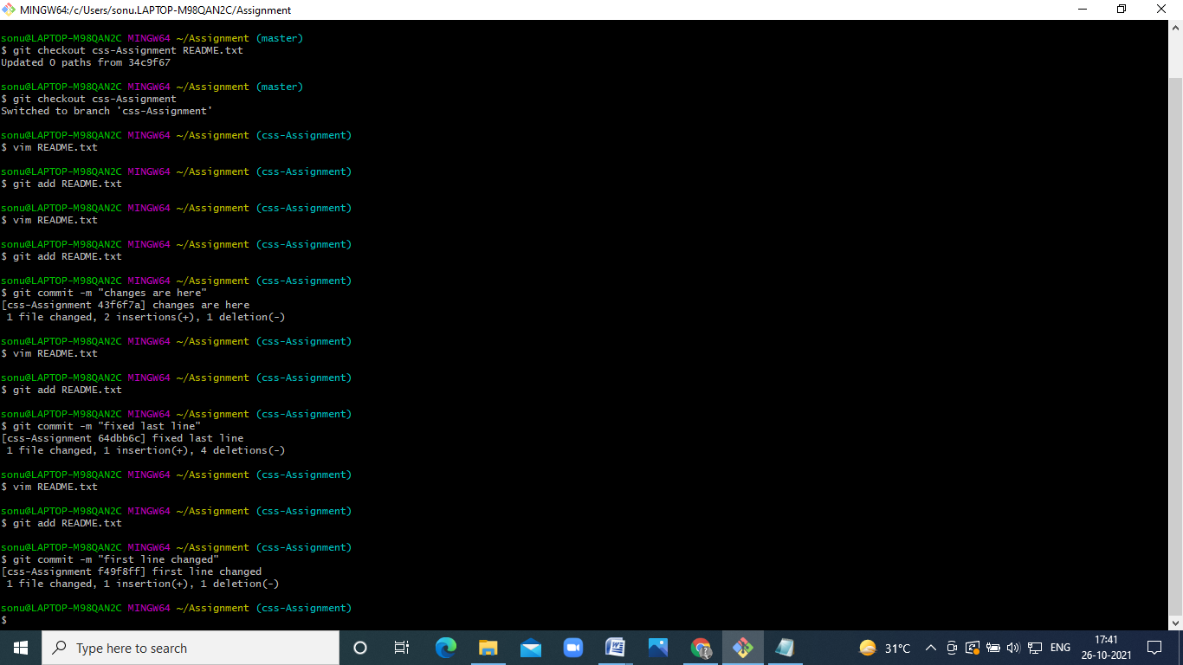

1. Commit those changed files.



1. Switch to master branch.

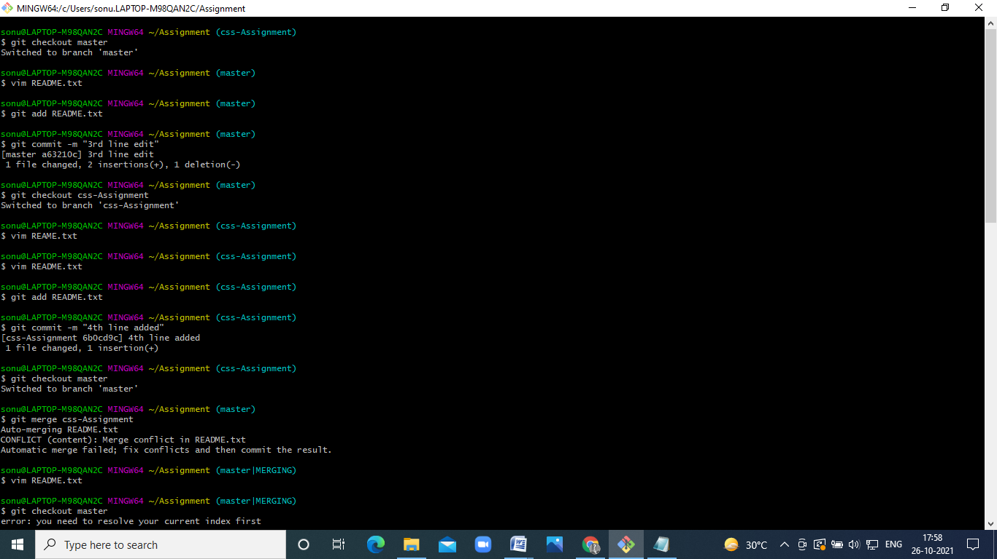

1. Make minor changes into README.txt file on line 3 & commit those changes into master.



1. Again switch to ‘css-assignments’ branch.



1. Make minor changes into few files belonging to ‘css-assignments’ branch.



1. Commit those changes.



1. Switch to master.

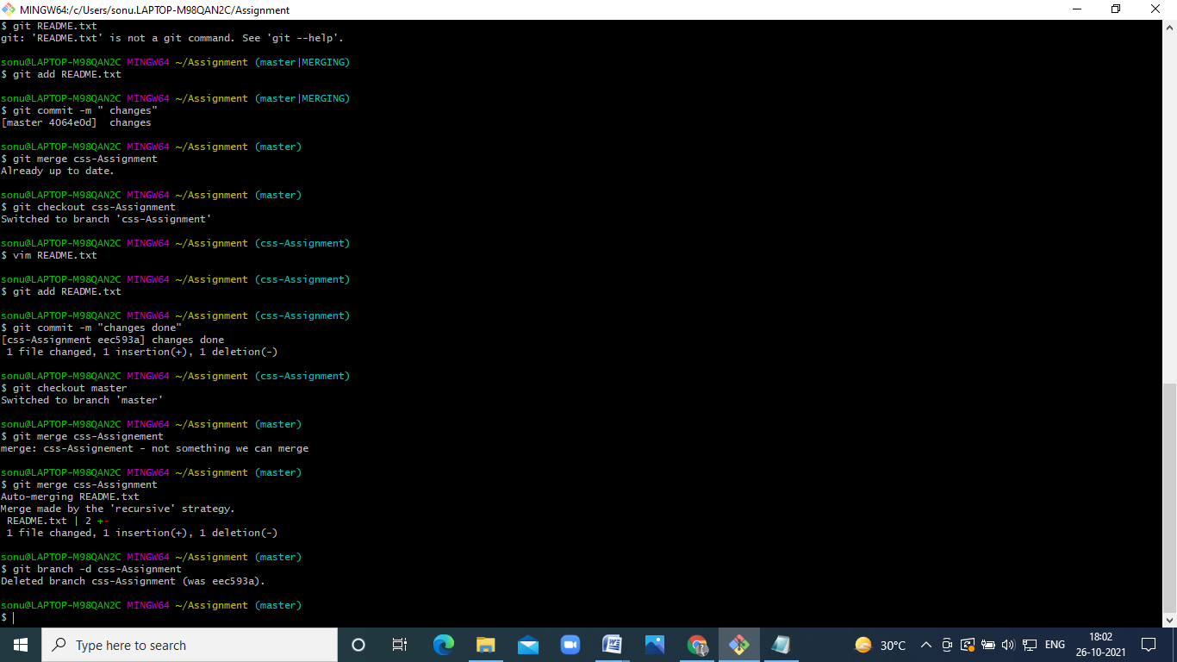

1. Merge ‘css-assignments’ branch into master. Confirm all css assignments are shown in master.



1. Finally delete the ‘css-assignments’ branch.



**Section 3**

